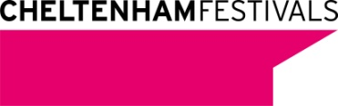
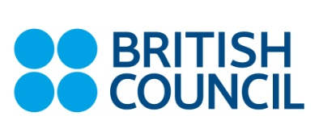

A young chemist is the new face of science in the Czech Republic

13. 5. 2013, Prague - Local scientist Jiří Dolanský was named the national winner of the FameLab competition and will represent the Czech Republic at the International Final at the Cheltenham Science Festival in the UK. Supported by the British Council, FameLab is providing this young chemist with the skills to share his research with a wider audience.
How do you make Borons fall in love? Making people fall in love is a tricky business and making Borons fall for each other is no different. In his three-minute talk chemist Jiří Dolanský explained the scientific methods he uses to overcome the initial misgivings of Borons and create long-lasting love.

Jiří Dolanský is currently working in a research group at the Institute of inorganic Chemistry AS CR in Řež, Czech Republic and studying for his Master‘s degree at the Faculty of Science, Charles University in Prague.

Communicating science accessibly and attractively is an ever-growing priority for researchers worldwide. Organised by the British Council in the Czech Republic in partnership with RSJ algorithmic trading FameLab helps young scientists acquire valuable skills to communicate their work to a non-scientific audience. By doing so, researchers not only change the common stereotype of the scientist as “the geek in the white lab coat busy doing strange things”, but also justify public funding for their research.

FameLab aims to discover charismatic, up-and-coming scientists who inspire people to see the world from a new perspective...in just three minutes. This is directly linked to the British Council’s aim to offer young people learning opportunities, help improve the quality of education and bring together current and future leaders to tackle issues facing society.

Second and third place were awarded to biologist Petr Jan Juračka and chemist Jan Havlík who also won the audience vote. This year’s finalists had chosen a mind-expanding selection of topics to bring under the microscope – from the new materials being used to make better teeth implants to the potential uses of terahertz spectroscopy in airport security.

The three-minute presentations were judged by a panel of scientists and communication experts according to FameLab’s golden rule - the 3C’s: Content, Clarity and Charisma. One of the biggest prizes for all finalists is the opportunity to attend a science communication master class lead by the best UK trainers in this area.

The FameLab winners from all participating countries will compete in June at the International Final at the Cheltenham Science Festival in the UK. FameLab is an initiative of the Cheltenham Festivals started in 2005 in partnership with NESTA and has quickly grown into arguably the world’s leading science communication competition. A partnership with the British Council since 2007 has seen the competition go global with more than 5,000 young scientists and engineers participating in over 23 different countries. NASA has license to deliver the competition in the USA. For more information about FameLab, please visit: http://www.famelab.org/ and www.britishcouncil.cz.

Notes to the Editor

The British Council creates international opportunities for the people of the UK and other countries and builds trust between them worldwide. We are a Royal Charter charity, established as the UK’s international organisation for educational opportunities and cultural relations. Our 7000 staff in over 100 countries work with thousands of professionals and policy makers and millions of young people every year through English, arts, education and society programmes. A quarter of our funding comes from a UK government grant, and we earn the rest from services which customers pay for, education and development contracts we bid for, and from partnerships. For more information, please visit: www.britishcouncil.org. You can also keep in touch with the British Council through http://twitter.com/britishcouncil and http://blog.britishcouncil.org.

RSJ algorithmic trading
RSJ algorithmic trading is one of the largest stock exchange derivatives traders in the world. The company uses its own mathematical models and algorithms to trade. All trading is conducted by fully automated software run on servers located in the data centres of stock exchanges. RSJ algorithmic trading is a purely Czech company with headquarters in Prague.
www.rsj.cz

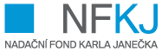

Karel Janeček’s Foundation
Karel Janeček’s Foundation for the support of scientific research & development was founded in June 2010. The founder of the foundation is Karel Janeček, the director of the company RSJ, an important Czech mathematician and benefactor. He aims his support at young scientists in the Czech Republic and successful Czech scientists who have decided to return from abroad.
www.nfkj.cz

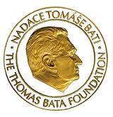

The Thomas Bata Foundation
The foundation’s mission is not only the preservation of the Bata history and tradition but also the support of projects aimed at a healthy development of communities in the areas of social and cultural development, youth education and entrepreneurial activities.
www.batova-vila.cz

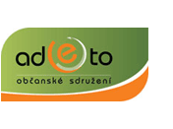

NGO ADETO
NGO ADETO is a non-profit organisation which tries to bring students and the public extraordinary encounters with exceptional people. The organisation also supports various projects concerning science communication and promotes international cooperation.
www.adeto.eu

Photos of this year’s contestants and past winners are available upon request.

Contact details:

- Dasa Sephton, Communications Officer, British Council, +420 605 882 555, dasa.sephton@britishcouncil.cz

